Outback Utes & Boots Darling Downs – Ute Show Entry Form

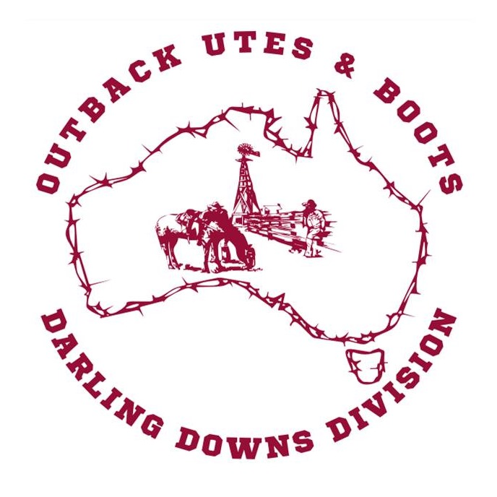
Event:
All Entrants must complete and submit an Entry Form prior to commencement of show judging.

Owner/Entrant Details:
Full Name
Address
Phone | Mobile: | Home:
Email

Vehicle Details:
Make/Model: |  | Registration No:
Vehicle Colour: | Year: |  | Cylinders:

Nomination fee: $5 per category

Major Classes (please tick)
BnS Ute |  | Work Ute |  | Chicks Ute |  | Classic Ute
Best 4X4 |  | Street Ute |  | Feral Ute

Sub Classes: (please tick)
Town & Country Ute |  | Themed Ute |  | Best Accessories
Best Holden Ute |  | Best Ford Ute |  | Best Bullbar
Other Make Ute |  | Loudest Exhaust (8, 6 & 4) |  | Ute with a Boot

Total $_________

Any entrant providing incorrect or misleading information will be disqualified.
Offensive or inappropriate behaviour will not be tolerated – you will be asked to leave

Entrants Declaration:
I have read and understood the Ute Muster Rules (see over) and agree to be bound in all respects by these Rules.

Signature of Entrant:________________________________ Date: __________
Signature of Official: ________________________________ Date: __________ 68
In this Waiver, Release and Acknowledgement Form “the Club” means “ Outback Utes and Boots” and includes all affiliated entities; servants or agents of the Club, all employees of the Club , all members of the Club and all volunteers of the Club and/or all affiliated entities.

By participating in the Event:

1. I acknowledge that it is a condition of participating in the Event that I do so at my own risk. I accept all risks and release the Club from all claims, demands and proceedings arising out of or connected with my participation in the Event and indemnify them against all liability for any injury, loss or damage arising out of or connected with my participation in the Event. This release continues forever and binds all of my heirs, successors, executors, personal representatives and assigns.

2. I acknowledge that it is a condition of participating in the Event that the Club and any person or body directly or indirectly associated with the Event are absolved from all liability arising for injury or damage to myself or my property howsoever caused arising out of my participation in the Event whatsoever whether due to any negligent act, breach of duty, default and/or omission on the part of the club and any person or body directly or indirectly associated with the Event, or otherwise.

3. I acknowledge that participating in the Event may involve a risk of serious injury or even death. I accept all risks necessarily flowing from participating in the Event.

4. I acknowledge that the Club relies on the information provided by me and state that all such information is accurate and complete.

5. I warrant that I am physically fit to participate in the Event and that I have not been advised otherwise by a qualified medical practitioner. I acknowledge that I must disclose any pre-existing medical or other condition that may affect the risk that either myself, or any other person will suffer injury, loss or damage.

6. I consent to receiving any medical treatment including ambulance transportation that the Club and any person or body directly associated with the Event think desirable as required during the event.

7. I acknowledge that it is a condition of participating in the Event that I follow the instructions of the Club and any person or body directly or indirectly associated with the Event at all times. I indemnify and keep indemnified the Club and any person or body directly or indirectly associated with the Event from all claims, demands and proceedings arising out of or connected with a failure by me to comply with rules and/or directions given to me by the Club and any person or body directly or indirectly associated with the Event.

If you are under the age of 18 years on the Event Day your parent or guardian must sign this declaration.

I certify that I am the parent/guardian of ___________________________ who will be ________ years of age on the day of the Event and that he/she has trained for and has my consent to participate in the Event. I testify that I have read the above and acknowledge acceptance of the stated conditions on behalf of the minor specified above. In consideration of the facilities provided to us, I myself, my executors, administrators and assigns and for the child/children/under
age person/s (if applicable) absolutely release and discharge the Club and any person directly or indirectly associated with the Event from all claims, demands and proceedings arising out of or connected with participation in the Event that I or the child/children/under age person/s may suffer or sustain

I ACKNOWLEDGE THAT I HAVE READ THIS FORM OR THAT IT HAS BEEN EXPLAINED TO ME. I FULLY UNDERSTAND ITS TERMS AND THAT I HAVE GIVEN UP SUBSTANTIAL RIGHTS BY SIGNING IT. I HAVE SIGNED THE DOCUMENTS FREELY AND VOLUNTARILY WITHOUT ANY INDUCEMENT MADE TO ME AND INTEND MY SIGNATURE TO BE A COMPLETE AND UNCONDITIONAL RELEASE OF ALL LIABILITY TO THE GREATEST EXTENT ALLOWED BY LAW.

Signed: ______________________________________ Date: _____________
69

